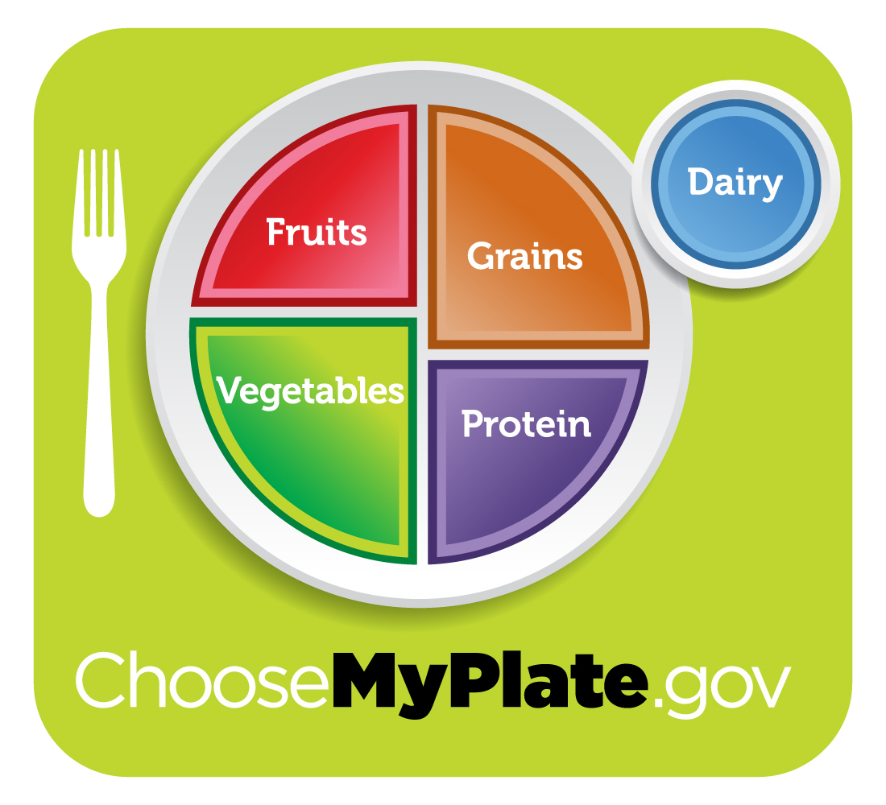
A Conversation with the Nutrition Pals

Pal #1: Let’s take a look at the Nutrition Recommendations and a helpful tool you can use to make sure you are getting enough of the good foods to help you grow!

Do you know the food groups? Who can name the food groups?

Pal #2: Let’s start by looking at the left side of the plate? Did you notice that it takes up half of the space on the plate? Each meal you have should consist of red, orange, and dark-green vegetables in main AND side dishes. What are some vegetables that fall into this category?

Pal #3: I always put a fresh fruit in my backpack and eat a piece of fruit as a snack every day. Dried, frozen, and canned fruits are great, too. Did you know there is a fruit snack made from dried grapes? Can you name it?

Pal#4: Do you see the orange section on the upper left side of the plate? That’s the grains group! What are some foods that would fall into the grains food group?

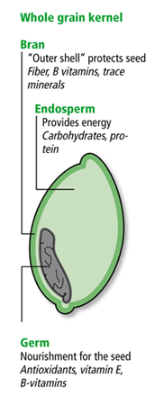
Grains are any food made from wheat, rice, oats, cornmeal, barley or another cereal grain product. Some examples are bread, pasta, oatmeal, crereal, and tortillas.

Pal #5: Grains fall into two groups, whole and refined. Whole Grains are are important because it contains all parts of the plant, where Refined Grains may only contain part of the plant. It is important to make at least half of your daily grain serving whole grains.

For more information about the grains group, you can go to www.choosemyplate.gov/foodgroups/grains.html#

Pal # 6: My favorite whole grain is lowfat popcorn! Did you know it actually turns itself inside out when it pops? It’s yummy!

Pal # 7: The last section of the plate is the protein group! Meat and beans provide protein, which is important in building muscles. Write “proteins” in the box below the meat and beans group. Can you think of some foods that belong to this group?

Pal #8: Did you know beans and pea are a part of the protein group AND the vegetables group? Beans and peas are excellent sources of protein AND fiber. These types of food are great for vegetarians and non-vegetarians alike!

Pal #9: Finally, did you notice the blue circle next to the plate? That is the dairy group. Did you know that foods in this group include more than just the milk we drink? They are foods made from milk. Can you name a few?

Pal #10: Why are some of the food groups bigger than others? Any thoughts?

