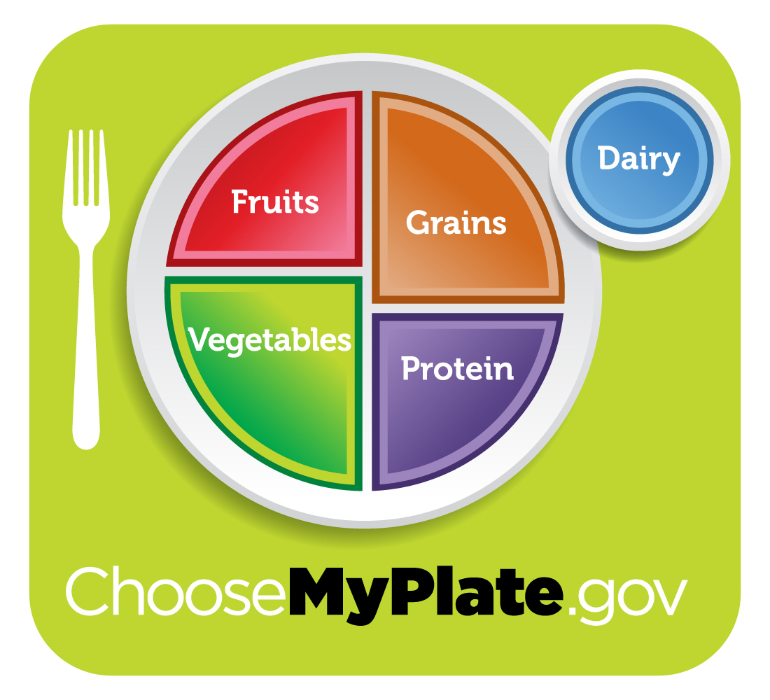
A Conversation with the Nutrition Pals

Pal #1: Let’s take a look at the Nutrition Recommendations and a helpful tool you can use to make sure you are getting enough of the good foods to help you grow!

Do you know the food groups? Who can name the food groups?

Wait and give time for the class to name the groups.
- Fruits
- Vegetables
- Protein
- Grains
- Dairy
Upon naming the food groups, introduce the “Choose my Plate Icon” and ask for observations.

Pal #2: Let’s start by looking at the left side of the plate? Did you notice that it takes up half of the space on the plate? Each meal you have should consist of red, orange, and dark-green vegetables in main AND side dishes. What are some vegetables that fall into this category?

Wait and give time for the class to name the red, orange, and dark-green vegetales
Explain the 5 different subgroups of vegetables. Information can be found at www.choosemyplate.gov/foodgroups/vegetables.html#
For more information about the health benefits of vegetables go to www.choosemyplate.gov/foodgroups/vegetables_why.html#
Information on fruits can be found at www.choosemyplate.gov/foodgroups/fruits.html

Make sure to explicitly remind students the “Key Consumer Message” is MAKE HALF OF YOUR PLATE FRUITS AND VEGETABLES

Pal #3: I always put a fresh fruit in my backpack and eat a piece of fruit as a snack every day. Dried, frozen, and canned fruits are great, too. Did you know there is a fruit snack made from dried grapes? Can you name it?

Pal#4: Do you see the orange section on the upper left side of the plate? That’s the grains group! What are some foods that would fall into the grains food group?

Wait for the class to give examples and for the teacher to provide additional information about grains.

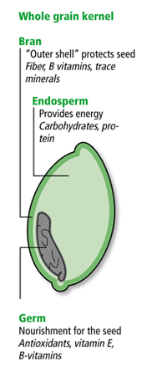
Grains are any food made from wheat, rice, oats, cornmeal, barley or another cereal grain product. Some examples are bread, pasta, oatmeal, crereal, and tortillas.

Pal #5: Grains fall into two groups, whole and refined. Whole Grains are are important because it contains all parts of the plant, where Refined Grains may only contain part of the plant. It is important to make at least half of your daily grain serving whole grains.

This is another opportunity to discuss the different parts of a seed which was talked about in the Plant Unit at the beginning of the year. Grains are the seeds of the plants. The OUTER CASING of the seed is the BRAN, the SMALL, PLANT-LIKE STRUCTURE is the GERM and the rest of the seed is the ENDOSPERM.

For more information about the grains group, you can go to www.choosemyplate.gov/foodgroups/grains.html#

Pal # 6: My favorite whole grain is lowfat popcorn! Did you know it actually turns itself inside out when it pops? It’s yummy!

Pal # 7: The last section of the plate is the protein group! Meat and beans provide protein, which is important in building muscles. Write “proteins” in the box below the meat and beans group. Can you think of some foods that belong to this group?

Wait for the class to give examples and for the teacher to provide additional information about the “meat and beans” group.

This is a good opportunity to remind students about making healthy choices when choosing foods from the group. Staying away from high-saturated fat proteins is important. Good Proteins include lean meats, fish, poultry, eggs, nuts and seeds.

Proteins are important as they serve as building blocks for bones, muscles, and skin.
For more information on the protein group, go to www.choosemyplate.gov/foodgroups/proteinfoods.html

Pal #8: Did you know beans and pea are a part of the protein group AND the vegetables group? Beans and peas are excellent sources of protein AND fiber. These types of food are great for vegetarians and non-vegetarians alike!

Pal #9: Finally, did you notice the blue circle next to the plate? That is the dairy group. Did you know that foods in this group include more than just the milk we drink? They are foods made from milk. Can you name a few?

Wait for the class to give examples and for the teacher to provide additional information about dairy products.

This group includes fluid milk products as well as any foods that are made from milk.

You should try to eat foods in this group that are low-fat (1% milk) or fat-free (skim milk)

Eating foods in the group, especially those with calcium, improves your bone health.

For more information about the dairy group, go to www.choosemyplate.gov/foodgroups/dairy.html

Pal #10: Why are some of the food groups bigger than others? Any thoughts?

Wait for the class to give share some ideas.

The larger the section of the plate for each food group shows that you should eat more foods from those groups and fewer foods from the groups with the smaller section.

