Single-Celled and Multi-Celled Living Things

Carefully observe the two pictures. Circle whether they are single-celled or multi-celled living things. On the lines provided, explain why you think so.





Circle One: Single-Celled Multi-Celled

Why do you think so?

_____________________________________________________________
_____________________________________________________________
_____________________________________________________________

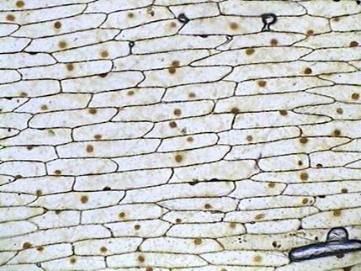

Circle One: Single-Celled Multi-Celled

Why do you think so?

_____________________________________________________________
_____________________________________________________________
_____________________________________________________________

Please use complete sentences to answer the following question.

How are the needs of single-celled living things like other plants and animals you have studied?
_____________________________________________________________
_____________________________________________________________
_____________________________________________________________
_____________________________________________________________

_____________________________________________________________
_____________________________________________________________
_____________________________________________________________
_____________________________________________________________

_____________________________________________________________
_____________________________________________________________
_____________________________________________________________
_____________________________________________________________

