Starry Night - Settings

Use the menu bar on the left side of the screen to adjust the following settings:

- Click Options:
  - Click the + Stars
    - Milky Way, Stars and labels should be checked, then click the – sign to close the box.

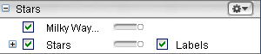

  - Click the + Constellations Sign
    - Check Labels, Stick Figures/Labels, then click the – sign to close the box.

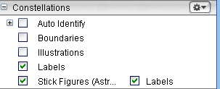

c. Click option tab to go back to sky screen.

The program should have opened to today’s date. This will display the night time sky for today.

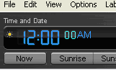
To Change the Time and Date:

- Click the hour. It will change to a pale blue color to let
you know that it’s selected.
- Type the digits you want displayed
- Repeat for the minutes and seconds
- Click the PM/AM to alternate between the two when needed

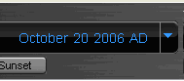
To Change the month, day and year:

- Click the Month
  - Use the up and down arrow keys on
keyboard to move forward or backwards

- Click the Day
  - Type the number you want displayed or use the up and down arrow keys on the keyboard to move forward or backwards.
  - Do the same for the year

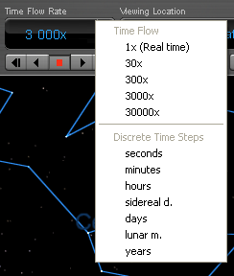
Selecting the “Time Flow Rate”:

Select from either Time Flow or Discrete
Time Steps by clicking the small triangle
next to the Time Flow Rate box. A pull down
menu will appear like the example here. →

Minutes is a good choice when running the
program for students, but you can change it
if needed.

To Change the Viewing Location to Chicago:
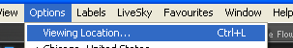
1. Go to “Options”
2. Select “Viewing Location”

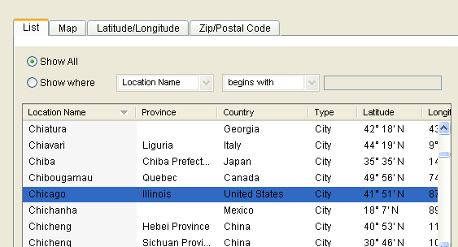

3. Select Chicago in the list

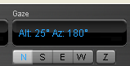
To Change the Viewing Directions:
Click the N S E or W buttons and it will
go there directly.
For this activity, select North

To “Play” the Night Sky:
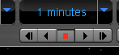
Select the forward or backward triangle to
continuously play.
Press the stop button to pause or stop the action.

Press the or button to move step by step forward or backwards.

Saving to Favorites

Go to file and select “Save.”
Choose “Save as a Favorite” and then give it a title such as “Lesson 18.”
This will save all of your settings for future use with this lesson.

