Starry Night - Settings

Use the menu bar on the left side of the screen to adjust the following settings:

- Click Options:
  - Click the + Stars
    - Milky Way, Stars and labels should be checked, then click the – sign to close the box.

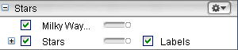

  - Click the + Constellations Sign
    - Check Labels, Stick Figures/Labels, then click the – sign to close the box.

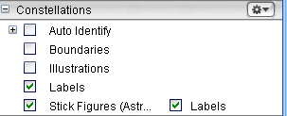

c. Click option tab to go back to sky screen.

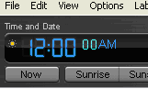
To Change the Time and Date:

- Click the hour. It will change to a pale blue color to let
you know that it’s selected.
- Type the digits you want displayed
- Repeat for the minutes and seconds
- Click the PM/AM to alternate between the two when needed

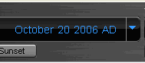
To Change the month, day and year:

- Click the Month
  - Use the up and down arrow keys on
keyboard to move forward or backwards

- Click the Day
  - Type the number you want displayed or use the up and down arrow keys on the keyboard to move forward or backwards.
  - Do the same for the year

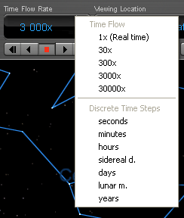
Selecting the “Time Flow Rate”

Select from either Time Flow or Discrete
Time Steps by clicking the small triangle
next to the Time Flow Rate box. A pull down
menu will appear like the example here. →

Minutes is a good choice when running the
program for students.

Saving to Favorites

Go to file and select “Save.”
Choose “Save as a Favorite” and then give it a title such as “Lesson 19.”
This will save all of your settings for future use.

