Starry Night - Settings

Use the menu bar on the left side to adjust the following settings:

- Click Options:
  - Click the + sign in front of Solar System
    - Planets and Labels should be checked, then click the - Solar System sign to close this box.
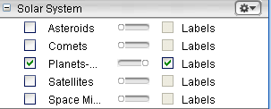

  - Click the + Stars
    - Milky Way, Stars and labels should be checked, then click the – sign to close the box.

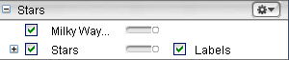

  - Click the + Constellations Sign
    - Check Labels, Stick Figures/Labels, then click the – sign to close the box.

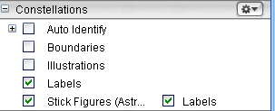

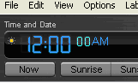
To Change the Time and Date:

- Click the hour. It will change to a pale blue color to let
you know that it’s selected.
- Type the digits you want displayed
- Repeat for the minutes and seconds
- Click the PM/AM to alternate between the two when needed

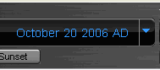
To Change the month, day and year:

- Click the Month
  - Use the up and down arrow keys on
keyboard to move forward or backwards
for this activity. ↓↑

- Click the Day
  - Type the number you want displayed or use the up and down arrow keys on the keyboard to move forward or backwards.
  - Do the same for the year

Saving to Favorites

Go to file and select “Save.”
Choose “Save as a Favorite” and then give it a title such as “Lesson 21.”
This will save all of your settings for future use.

