Name: _____________________________ Period: _______

1. State whether or not the following statement is true or false and then defend your answer based what you have learned about locating the epicenter of an earthquake. “Seismologists often use data from two seismic stations to determine the epicenter of an earthquake”. Be sure to include at least 2 reasons for your decision!
____________________________________________________________________________________________________________
____________________________________________________________________________________________________________
____________________________________________________________________________________________________________
____________________________________________________________________________________________________________

2. Using the graph below answer the following questions.
a. Label the P-wave and S-wave on the graph.
b. When did the S-wave arrive? ______________
c. When did the P-Wave arrive? ______________
d. What is the amplitude of the P-wave? ______________
e. Which wave appears to be stronger? ______________ How did you know?__________________________________
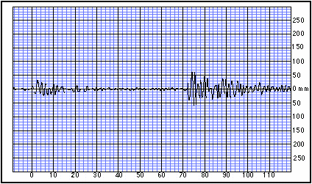
Seconds
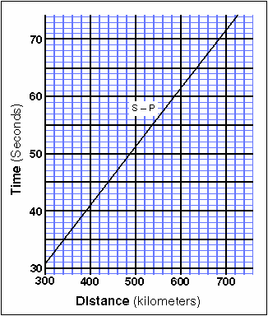

3. Using the graph to the right, answer the following questions.

- If a seismologist knew that it took 35 seconds for the
S-P Interval (the time difference between the arrival
times of the two waves), why would this graph be
VERY useful to the seismic station? In other words,
what other information can this graph tell them?
________________________________________
________________________________________

- What data (in kilometers) would we be able to send
to other seismic stations based on the fact that the
S-P Interval was 35 seconds?

________________________________________
________________________________________

