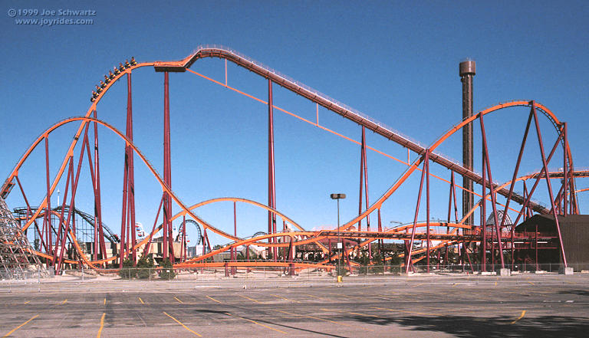
Can you name this ride at 6 Flags?

CRAZY COASTERS

A GROUP ROLLER COASTER PROJECT

You are a member of a design engineering team whose task it is to come up with a design for a roller coaster using a marble “coaster car” running on a pipe insulation track. You will then create a presentation of your design, with references to as many physics principles operating in the running of such a coaster. Your design must meet the following specifications:

- 2 hills (including the first drop).
- 1 loop
- 1 break or jump
- A big finish

Your entire task includes the following:

- A built model of the working coaster. You will have access to pipe insulation sections, masking tape, materials to prop up your coaster hills, marbles, and other materials to
build your working model. You are to make a sign for your coaster including the name of the coaster and colorful background. Your teacher will take a photo of your coaster with your sign and the group “builders”.

- A poster sized colorful drawing of your model with vocabulary from your research log, showing where the principles of physics (motion and forces) are being demonstrated. A few terms are shown below but many more terms can be applied.

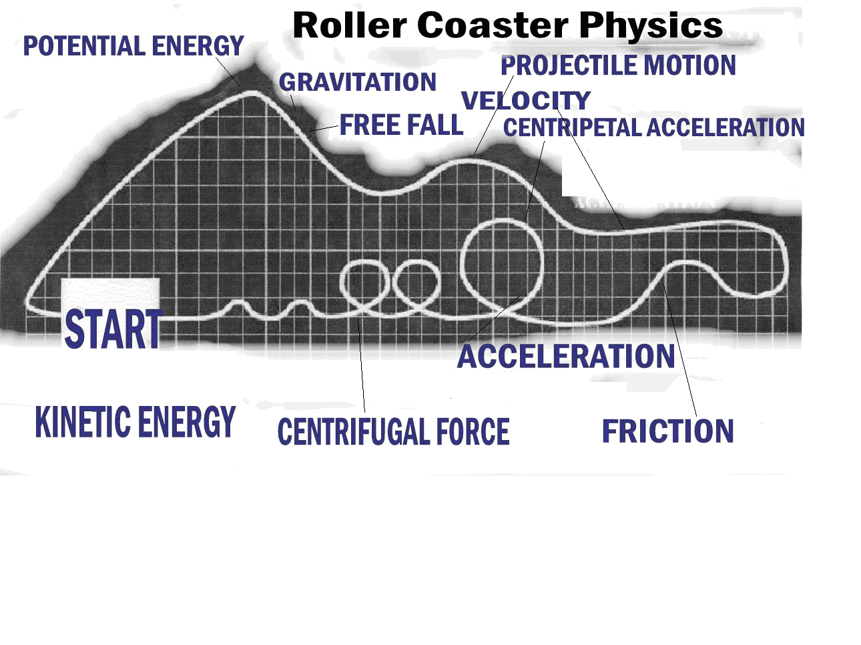
- A group presentation that includes your poster, sign, and an original dramatic story of what happens to the marble as it goes through your coaster.

Do a “personification” story of the marble’s ride along your coaster where you point out the principles of physics along the way. Give the marble human characteristics as it experiences your thrill ride.

- Have one person hold up the poster for the telling of the story.
- Have another person hold up the coaster sign.
- Have a third person tell the story of going down the first hill and up the second and into the loop.
- Have another person continue the story as the marble travels over the break or jump and into the big finish.

Your presentation must include the information above. If you have another idea that includes all of the components, please see the teacher for approval.

